Rough Terrain 3 Wheel Electric Bike

We have just entered the dawn of ebikes in 2020. Ebikes are the future of transport due to low transport cost as compared to petrol diesel bikes and are environment friendly. But all ebikes that we see around us work on 2 wheels. 2 Wheel bikes are used by many but many people who have issues balancing and need to strain their legs at every stop.

So here we design a smart 3 wheeled geared bike with double suspension for rough terrain as well as high speed riding. Our ebike is designed using a unique innovative 3 wheel design where front front 2 wheels are connected in a separate frame and the bike handle and body rest on the mechanism through a unique suspension joint linkage setting.

This ensures the body is isolated from the front wheel jerks. Also the front wheels can adjust over rough terrains or puddles by slanting their angles. When one wheel adjusts its angle the body weight is transferred over the other front wheel thus ensuring minimum jerks.

The back wheel is driven by a electric motor attached through a gearbox. The gearbox allows user to choose right gear as per the terrain/slope. This ensures the bike provides enough power while climbing or rough terrains and does not stall. At higher gears the bike can speed up on normal roads to reach high speeds.

It is powered by a lithium battery and a controller circuitry to drive motor as per the throttle provided by user. The back wheel is also attached to the seat and body of bike through a suspension in order to avoid heavy jerks to rider. Apart from this the e bike is integrated with unique headlights and comfortable seat to provide a good riding experience.

Components

- High Power Motor
- Shaft Rod
- Motor Mount
- Gearbox
- Shock Absorbers
- Seat
- Headlights
- Clutch
- Brakes
- Throttle
- Handle
- Battery
- Motor Controller
- Connecting Rods
- L Angles
- Mounts and Joints
- Supporting Frame
- Base Frame
- Screws and Bolts

Advantages

- Works on Rough Terrain as well as High Speed on Roads
- Easy to Balance
- Unique Double Front Tyre Suspension System
- No Pollution No Noise

Disadvantages

- Requires Battery Charging

Block Diagram
Front View

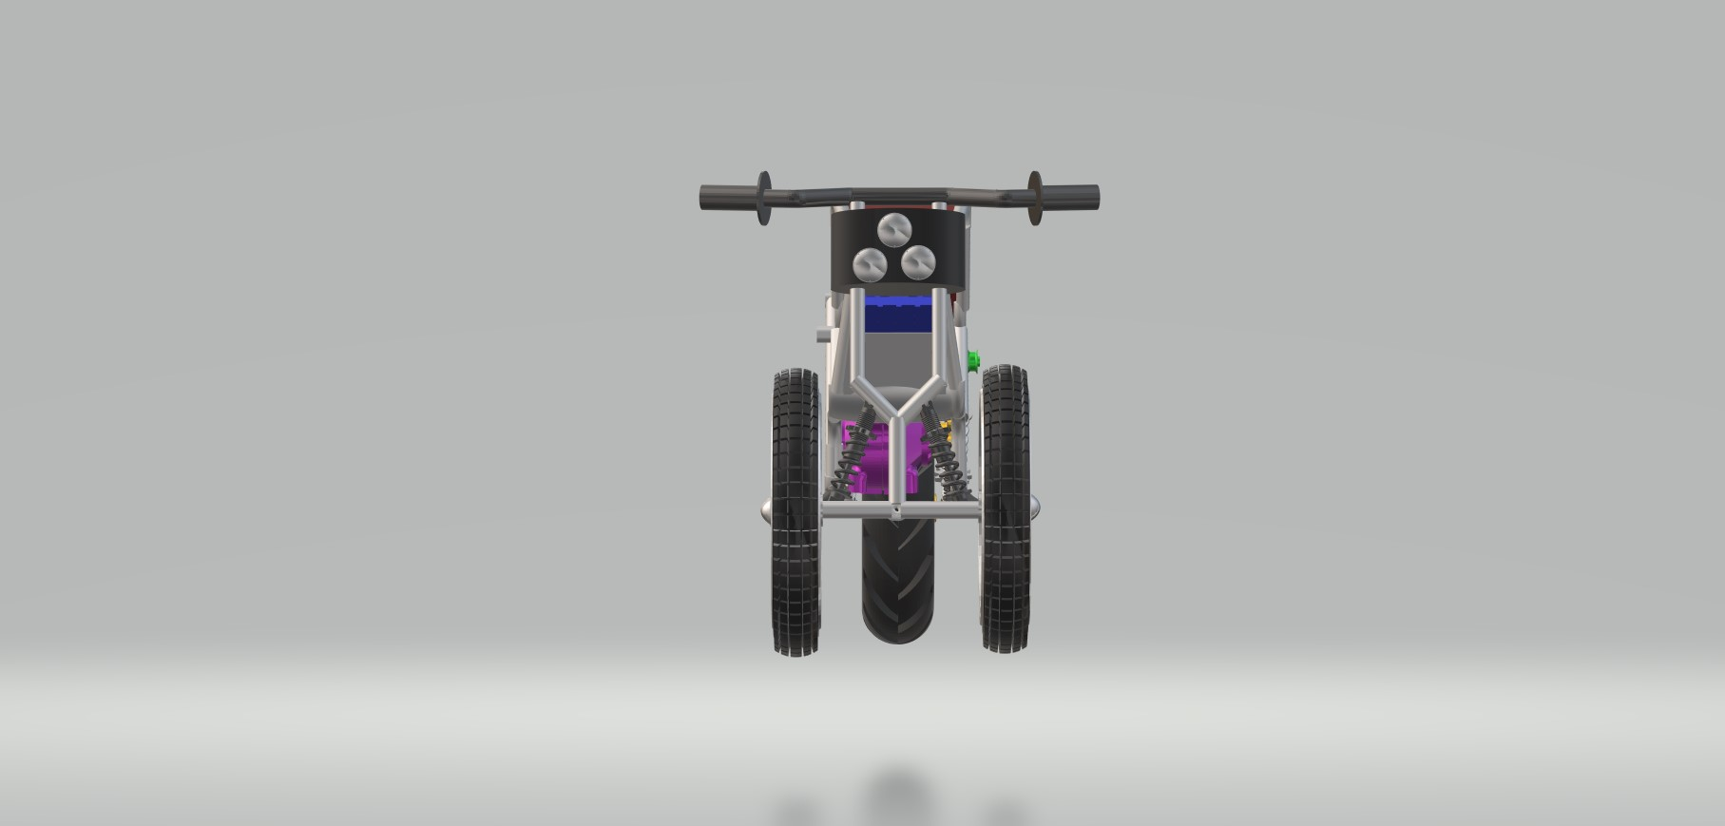

Side View

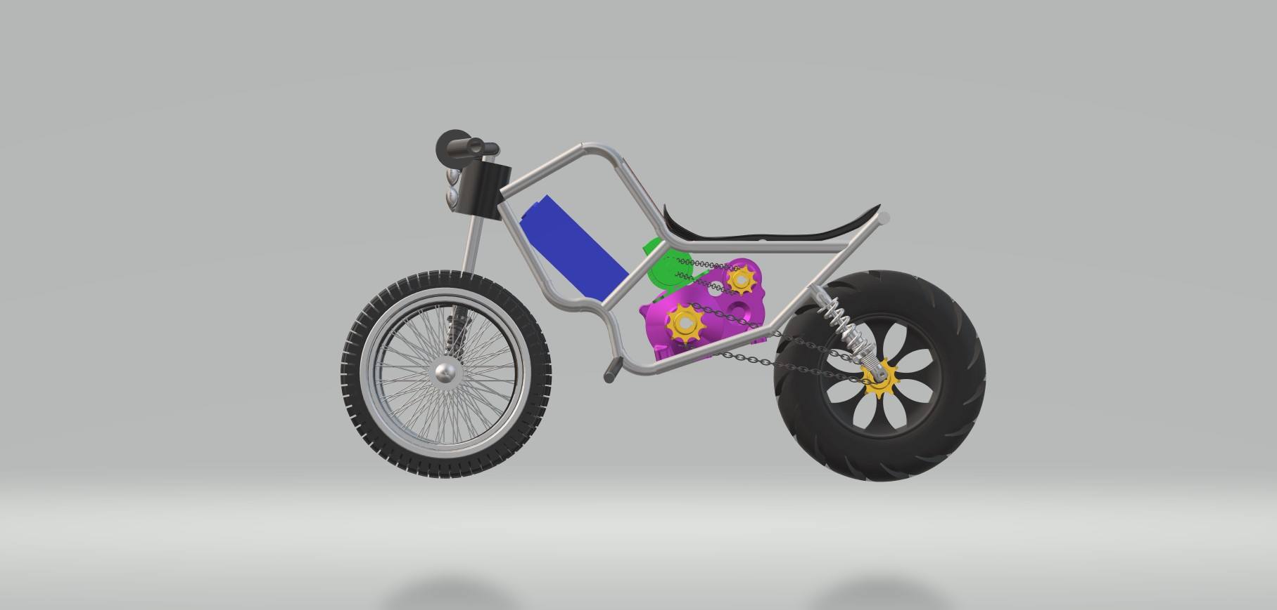

3D View

